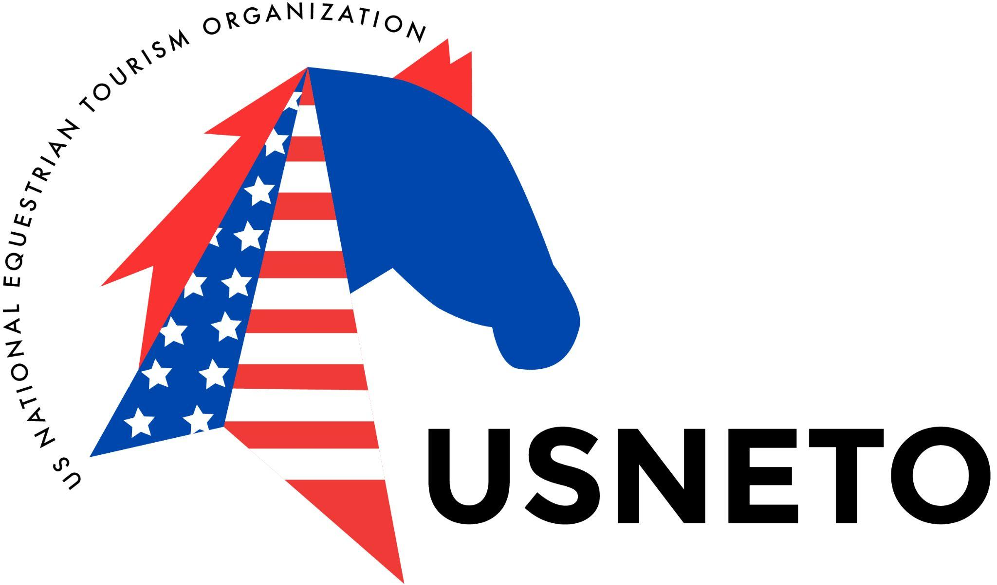
PO Box 213
Laurinburg, NC 28353

APPLICATION FOR TREC USA RECOGNIZED EVENT

Event organizers are encouraged to apply for recognition of their events. Any TREC USA member may apply to organize a TREC USA recognized event. Organizers of recognized events must refer to the Event Organizers Handbook 2021 and the USNETO/TREC-USA Sports Rulebook for detailed event requirements. Applications for recognition must be submitted at least 30 days prior to the proposed event. A $25 application fee must accompany the application form.

Name of Event __________________________________
Proposed Event Date ____________ Rain date_________
Event location ___________________________________
Organizer's Name _______________USNETO #________
Organizer's Address _______________________________
Organizer's Email________________Phone_____________

Type of Event: ____ Official (put on by organization) ____ Member organized event
Planned activity: ____ Ridden ____ Driven ____ Both
____ 3 Phase TREC competition
____ 2 Phase TREC competition
____ Orienteering
____ Control of Pace
____ Obstacles
____ Other (describe) ______________________________
Additional pages may be used for more detailed descriptions of planned events.

Proposed officials:
Judge(s) _________________________________________
Technical Delegate (TD) _____________________________
Trainer for Educational Events ________________________

Has the applicant organized previous TREC-USA recognized events? ____ yes ____ no If no, please include a written reference from someone familiar with the organizer's equine event organizational experience.

First time organizers must work with a TREC-USA TD for competitions or a member experienced with the type of activity planned.
Name of TD or Experienced Member ___________________

INSURANCE
Insurance requirements are detailed in Section IV of the Event Organizers Handbook. Organizers must familiarize themselves with these provisions and then answer the following questions.
1) Dates and times for which insurance will be required _________________________________ 2) Name(s) of the facility or individuals for which insurance will be required
________________________________
3) Does the location/facility have insurance greater than or equal to TREC-USA policy coverage limits? Y/N If yes, will they add TREC-USA as an additional insured? Y/N If yes, and if the USNETO Treasurer receives a certificate of coverage 2 weeks in advance of the event, and if, our underwriter approves the coverage the requirements for USNETO insurance may be waived. If so, recognition fees may be reduced by 50%.

I ________________________, organizer of the proposed TREC-USA recognized event, agree to familiarize myself with all of the provisions of the Event Organizers Handbook . In addition I agree to adhere to the requirements of the TREC-USA Sports Rulebook and the FITE International Competition Rules as well as the guidelines outlined in the Event Organizers Handbook including payment of Event Fees within two weeks following approval of the event.

Signature _____________________________________
Date ____________________

Please return the completed form to: USNETO/TREC-USA
PO Box 213
Laurinburg, NC 28353
Or email to: usneto.trecusa@gmail.com

